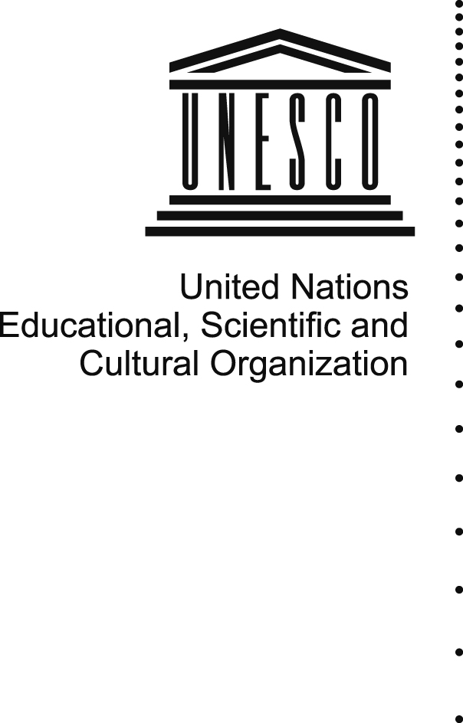 | 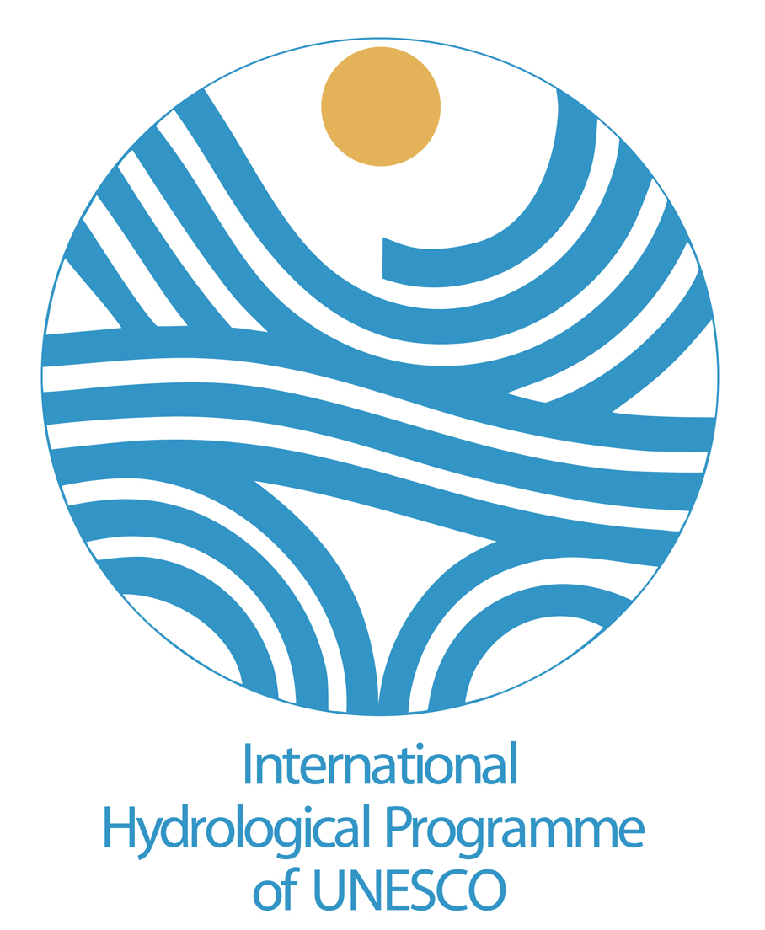  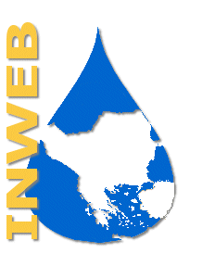  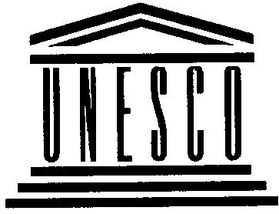  PCCP-SEE

Preparatory meeting for the implementation of the PCCP
Courses in South East Europe

Organised by UNESCO-PCCP with
UNESCO Chair and International Network of Water-
Environment Centres for the Balkans
At
The Aristotle University of Thessaloniki
Department of Civil Engineering
Division of Hydraulics & Environmental Engineering
Thessaloniki 54124, Greece
On
3-4-5 May 2006

AGENDA

May 3rd 2006

09:30 Welcome

Opening session and adoption of the agenda
Prof Jacques Ganoulis

General presentation of the PCCP project and of the meeting’s objectives
Léna Salamé

11:00 Coffee-break

11:30 Draft one year time table proposal presentation and adoption

Brainstorming session: objectives, focus and length of the course

13:00 Lunch

14:00 Course documents regionalisation: Course book (which parts should be kept, taken out or modified; any additions)

16:00 Coffee-break

16:30 Course documents regionalisation: Reading (which parts should be kept, taken out or modified; any additions)

18:00 End of session

May 4th 2006

9:00 Course documents regionalisation: Handouts (which parts should be kept, taken out or modified; any additions)

10:30 Coffee-break

11:00 Course implementation: participants, institutions, trainers

12:30 Lunch

14:00 Identification of new theoretical material, case studies and role plays

16:00 Coffee break

16:30 Division of the roles: coordination, documents writing and documents research, editing

18:00 End of session

May 5th 2006

09:00 Time table revision, budgetary issues

10:30 Coffee-break

11:00 Future communications

12:30 Greetings
Prof Jacques Ganoulis and Léna Salamé

PCCP-SEE

First preparatory meeting: List of Participants

PCCP-SEE

Preparatory meeting for the implementation of the PCCP
Courses in South East Europe

Organised by UNESCO-PCCP
With
UNESCO Chair and International Network of Water-
Environment Centres for the Balkans
At
The Aristotle University of Thessaloniki
Department of Civil Engineering
Division of Hydraulics and Environmental Engineering
Thessaloniki 54124, Greece
On
3-4-5 May 2006

LIST OF PARTICIPANTS

Bogdanovic Slavko
Independent Non-State University
Ilije Ognjanovica 4
21 000 Novi Sad
Serbia and Montenegro

Ganoulis Jacques
Aristotle University of Thessaloniki
Faculty of Engineering
Department of Civil Engineering
Division of Hydraulics and Environmental Engineering
Thessaloniki 54 124
Greece

Kolokytha Elpida
Aristotle University of Thessaloniki
Faculty of Engineering
Department of Civil Engineering
Division of Hydraulics and Environmental Engineering
Thessaloniki 54 124
Greece

Mylopoulos Ioannis
Aristotle University of Thessaloniki
Faculty of Engineering
Department of Civil Engineering
Division of Hydraulics and Environmental Engineering
Thessaloniki 54 124
Greece

Zizanovic-Dakic, Melita
Ministry of Foreign Affairs of the Republic of Croatia
Dinarska 32
10 000 Zagreb
Croatia

Hacker Corinna-Rosa
PCCP Project
Division of Water Sciences
UNESCO
1 rue Miollis
75015 Paris
France

Salamé Léna
PCCP Project Coordinator
Division of Water Sciences
UNESCO
1 rue Miollis
75015 Paris
France

Quartano Katie
UNESCO Chair and Network INWEB
Aristotle University of Thessaloniki
Faculty of Engineering
Department of Civil Engineering
Division of Hydraulics and Environmental Engineering
Thessaloniki 54 124

